TESTING DOCUMENTATION
Manual Testing of Library APP

Test Summary
Total Test : 7
Total Pass : 7
Success Rate : 100%

Test Category
Interface Testing
- Main Menu Navigation
Book Catalog Management
- View Catalog
- Add, Edit, an Remove Books
- Filter search in Catalog
Loan & Return Management
- Loan book to user
- Return book from user
User Management
- Add, Edit, an Remove User
Business Logic
- Test Overdue and Returned Late

TEST CASE 1
MAIN MENU NAVIGATION

Priority : High
Type : Functional

Precondition
- App is running
- Login with admin/admin
- Database has sample data
- Xampp is running
Steps
- Click on other forms
Expected
- Fast transition to other forms
- Near no delay
- All elements are rendered
- No data leaks
Result: [PASS]
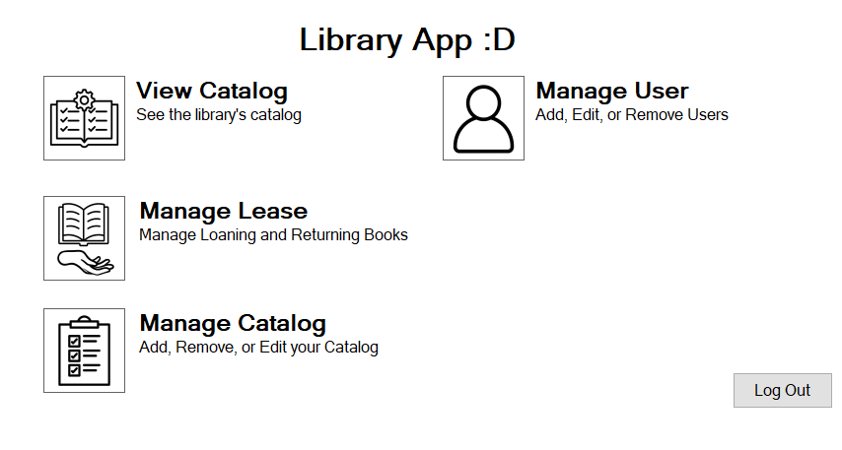

TEST CASE 2
VIEW CATALOG

Priority : High
Type : Functional

Precondition
- App is running
- Login with admin/admin
- Database has sample data
- Xampp is running
- In the [View Catalog] Form
Steps
- Click on Catalog
- Wait till it loads
Expected
- All data from database is loaded
Result: [PASS]
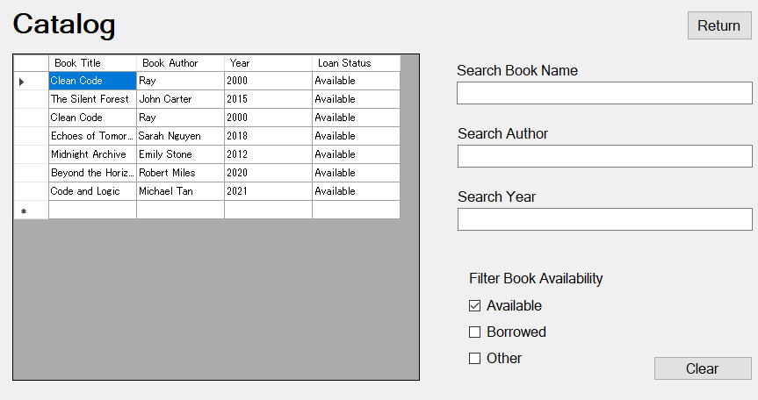

TEST CASE 2
ADD, EDIT, REMOVE BOOK

Priority : High
Type : Functional

Precondition
- App is running
- Login with admin/admin
- Database has sample data
- Xampp is running
- In the [Manage Catalog] Form
Steps
- Fill Input & Add Book
- Click on a book & Edit content
- Delete another book
Expected
- Successfully added a book
- Successfully edited a book
- Successfully removed a book
Result: [PASS]
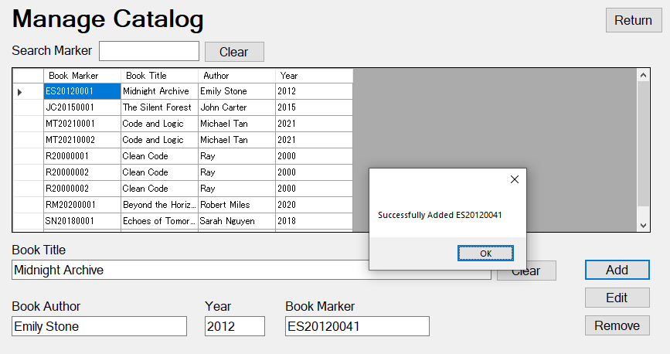
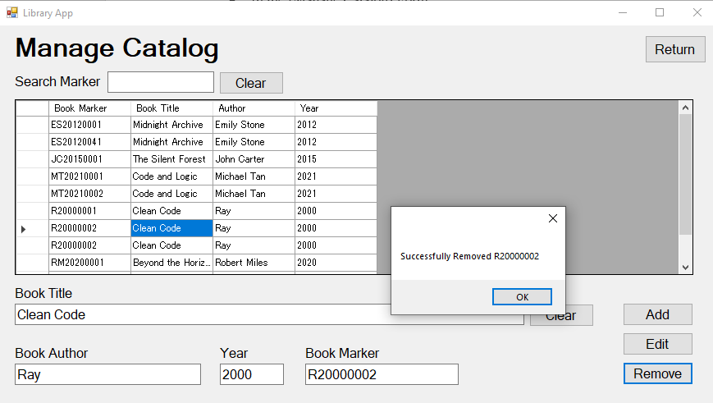
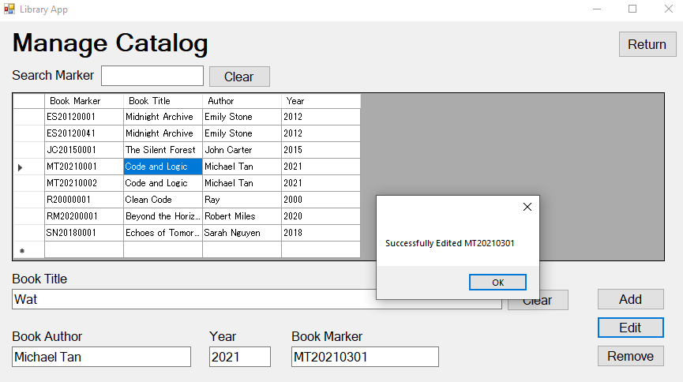

TEST CASE 3
FILTER SEARCHING

Priority : High
Type : Functional

Precondition
- App is running
- Login with admin/admin
- Database has sample data
- Xampp is running
- In the [View Catalog] Form
Steps
- Wait till all books load
- Filter search using either title, year, or author
Expected
- Successfully filtering
Result: [PASS]
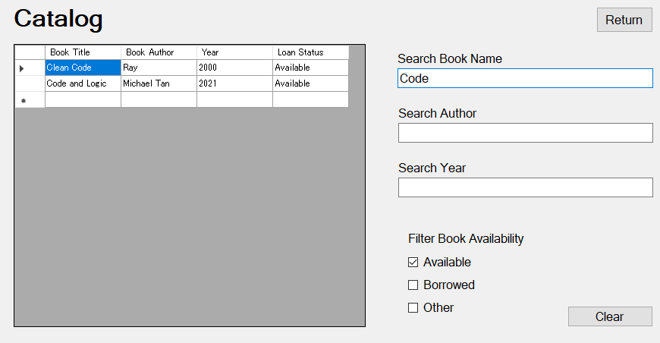

TEST CASE 4
LOAN BOOK TO USER

Priority : High
Type : Functional

Precondition
- App is running
- Login with admin/admin
- Database has sample data
- Xampp is running
- In the [Manage Lease] Form
Steps
- Select a user
- Select a book in the availability table
- Click [Loan Book]
Expected
- Book should be on the history table now
Result: [PASS]

TEST CASE 5
RETURN BOOK FROM USER

Priority : High
Type : Functional

Precondition
- App is running
- Login with admin/admin
- Database has sample data
- Xampp is running
- In the [Manage Lease] Form
- User needs to have borrowed a book
Steps
- Select a user
- Select a book in the history table
- Click [Return Book]
Expected
- Book should go back to the availability table
Result: [PASS]

TEST CASE 6
ADD, EDIT, AND REMOVE USER

Priority : High
Type : Functional

Precondition
- App is running
- Login with admin/admin
- Database has sample data
- Xampp is running
- In the [Manage Lease] Form
Steps
- Fill Input & add user
- Click on a user & Edit content
- Delete another user
Expected
- Successfully added user
- Successfully edited user
- Successfully removed user
Result: [PASS]
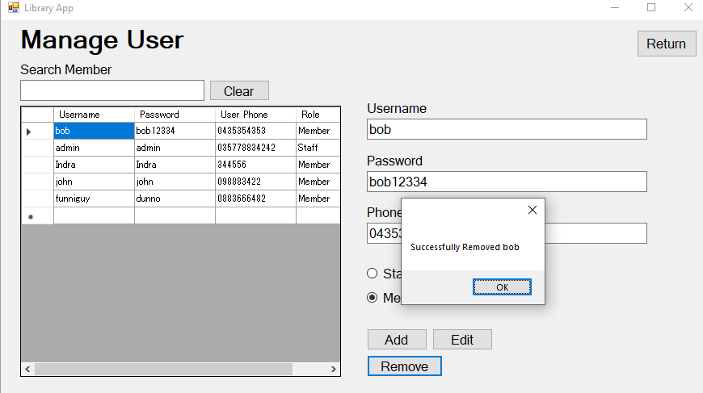
TEST CASE 7
OVERDUE TEST

Priority : Medium
Type : Non-Functional

Precondition
- App is running
- Login with admin/admin
- Database has sample data
- Xampp is running
- In the [Manage Lease] Form
- User needs to be 7 days since the borrow date
Steps
- See If the user is overdue
Expected
- Should display overdue
Result: [PASS]

